Operating System project report

Team work:

Section: 3 Group :3

* Maria Ezat Wanis
* Marina Ehab Halim
* Mary Kamal Bebawy

-In our project we have five classes (Mini-FAT , VirtualDisk , Directory , Directory_Entry , FileEntry , program(contains class commands))

1. **Mini**-**FAT** :

We have 9 methods in this class

* Constractor
* prepareFat:to initialize the content of clusters in mini fat
* write_fat_table:to write in fat clusters
* get_Fat_Table: to read fat clusters
* print_Fat_Table : to print the fat table
* get_empty_cluster: to show each empty cluster in the fat table
* get_empty_clusters: to return the index of each empty cluster in the fat table
* set_cluster_status: to change the value of specific index
* get_cluster_status: to get the value of specific index

1. **VirtualDisk** :

We have 4 methods in this class

* Intialize: Make sure that if the file is present or not, if it is not there, then create it, but if it is, read the files inside it
* write_cluster:
* read_cluster:
* getFreeSpace:get the remaining free space of disk

1. **Directory** :

We have 14 methods in this class

* Constractor
* WriteDirectory:to write in the directory
* ReadDirectory:to read from the directory
* updateContent: to update new item in this directory in specific index
* GetDirectory_Entry : to get information about the directory
* deleteDirectory: to delete the directory
* searchDirectory: to search about specific directory or file in the directory
* GetEntrySize: to return the “ ?? ” size
* get_size_on_Disk :
* Can_add_Entry: if we can add a file or directory to this directory
* updateInfo: replace the old directory /file by new one
* RemoveEntry: to delete specific file or directory in that directory
* addEntry: to add new file or directory in the directory
* EmptymyCluster:

1. **Directory_Entry :**

We have 3 methods in this class

constractor

getbytes:

Get_Directory_Entry :

1. **FileEntry :**

We have 8 methods in this class

* Constractor
* printFileContent: to print the content of the file
* GetDirectory_Entry : : to get information about the directory
* get_size_on_Disk :
* EmptymyCluster:
* WriteFileContent: to write in the file
* ReadFileContent: to read from file
* deleteFile: to delete file

1. **Program :**

We have 13 methods in this class

* Md: Creates a directory.
* Rd: Removes a directory.
* Cd: Change the current default directory to the directory given in the argument.
* Dir: List the contents of directory given in the argument. If the argument is not present, list the content of the current directory. If the directory does not exist an appropriate error should be reported.
* Import: import text file(s) from your computer.
* Rename: Renames a file.
* Del: Deletes one or more files.
* Type: Displays the contents of a text file.
* Export: export text file(s) to your computer.
* Cls: Clear the screen.

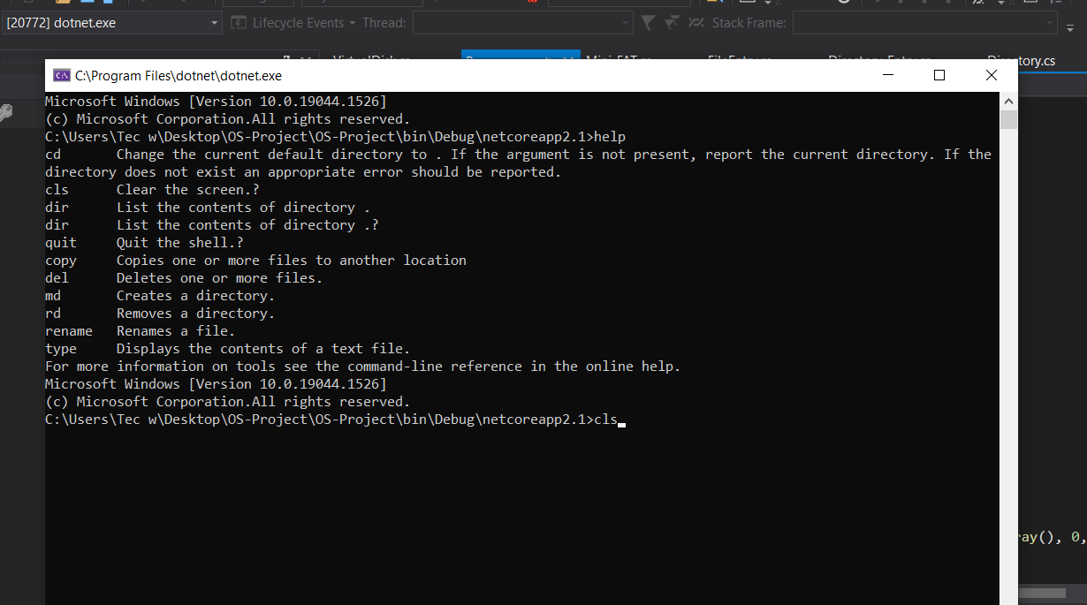

After run

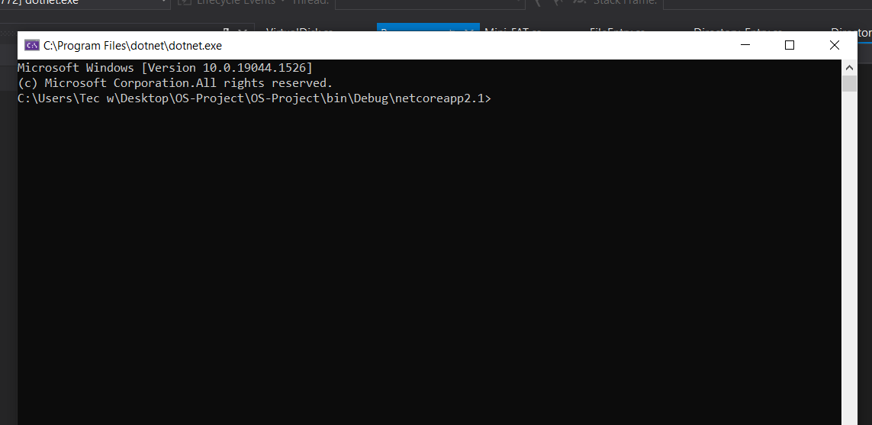

* Help: Provides Help information for commands.

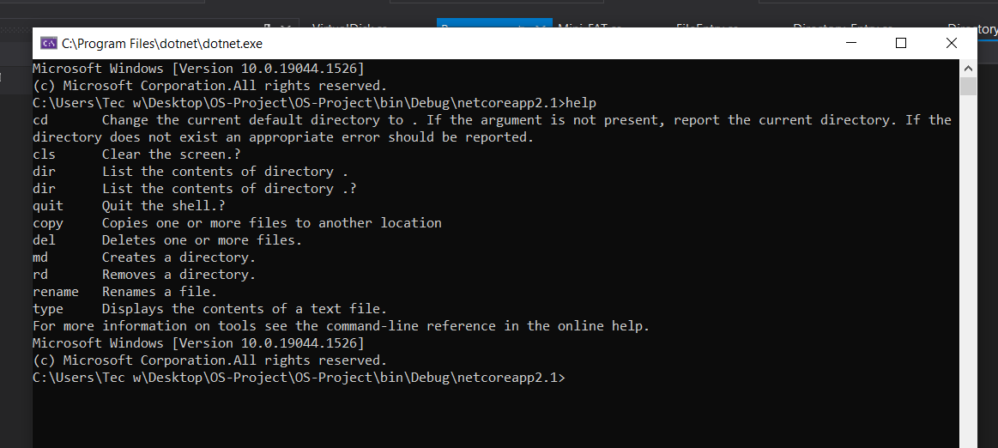

* Quit: Quit the shell.

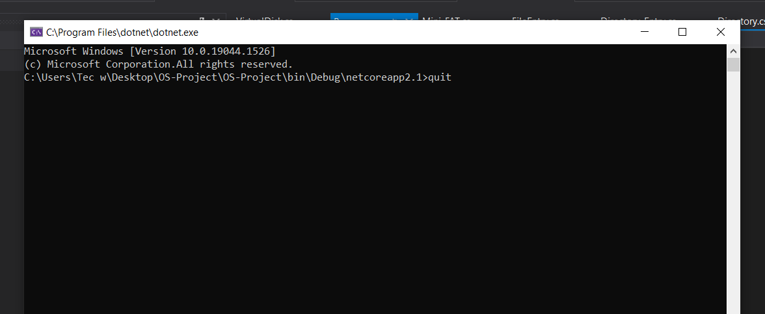

After run

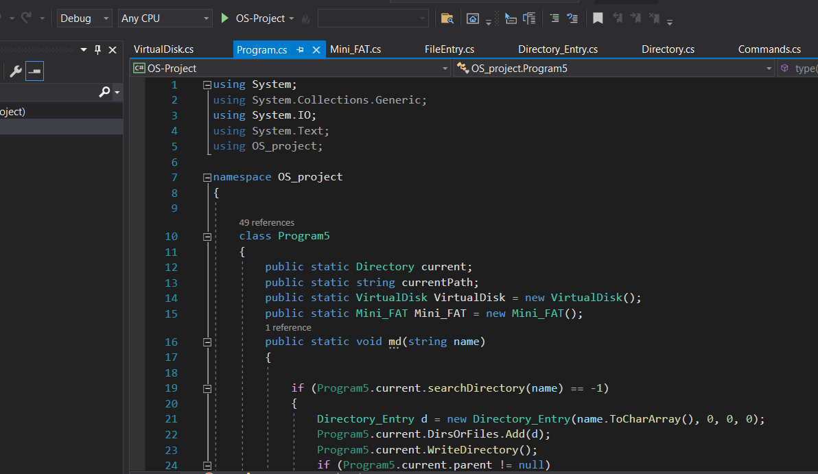

* Copy: Copies one or more files to another location.